Practical 1:-

import cv2

import numpy as np

## Read, Show, Greyscale, Rotate, Shape, Resize

# load image using imread

img = cv2.imread(r"assets\Lenna.png", cv2.IMREAD_COLOR)  # Flag = 1

img2 = cv2.imread(r"assets\Lenna.png", 0)   # Flag = 0 is cv2.IMREAD_GRAYSCALE

# Flag -1 is cv2.IMREAD_UNCHANGED

cv2.imshow("lena_img", img)   # lena_img is the window name

cv2.waitKey(100)     # Waits for a key to be pressed to close the window

cv2.imshow("lena_img_grey", img2)

cv2.waitKey(100)

img3 = cv2.rotate(img, cv2.ROTATE_90_CLOCKWISE)

cv2.imshow("rotate_img", img3)

cv2.waitKey(100)

img4 = cv2.rotate(img2, cv2.ROTATE_90_CLOCKWISE)

cv2.imshow("rotate_img_2", img4)

cv2.waitKey(100)

(h,w,d) = img.shape

print('width = {}, height = {}, depth = {}'.format(w,h,d))

new_img = cv2.resize(img, (300,200))

cv2.imshow("Resized1", new_img)

cv2.waitKey(0)

cv2.destroyAllWindows()

OutPut:-

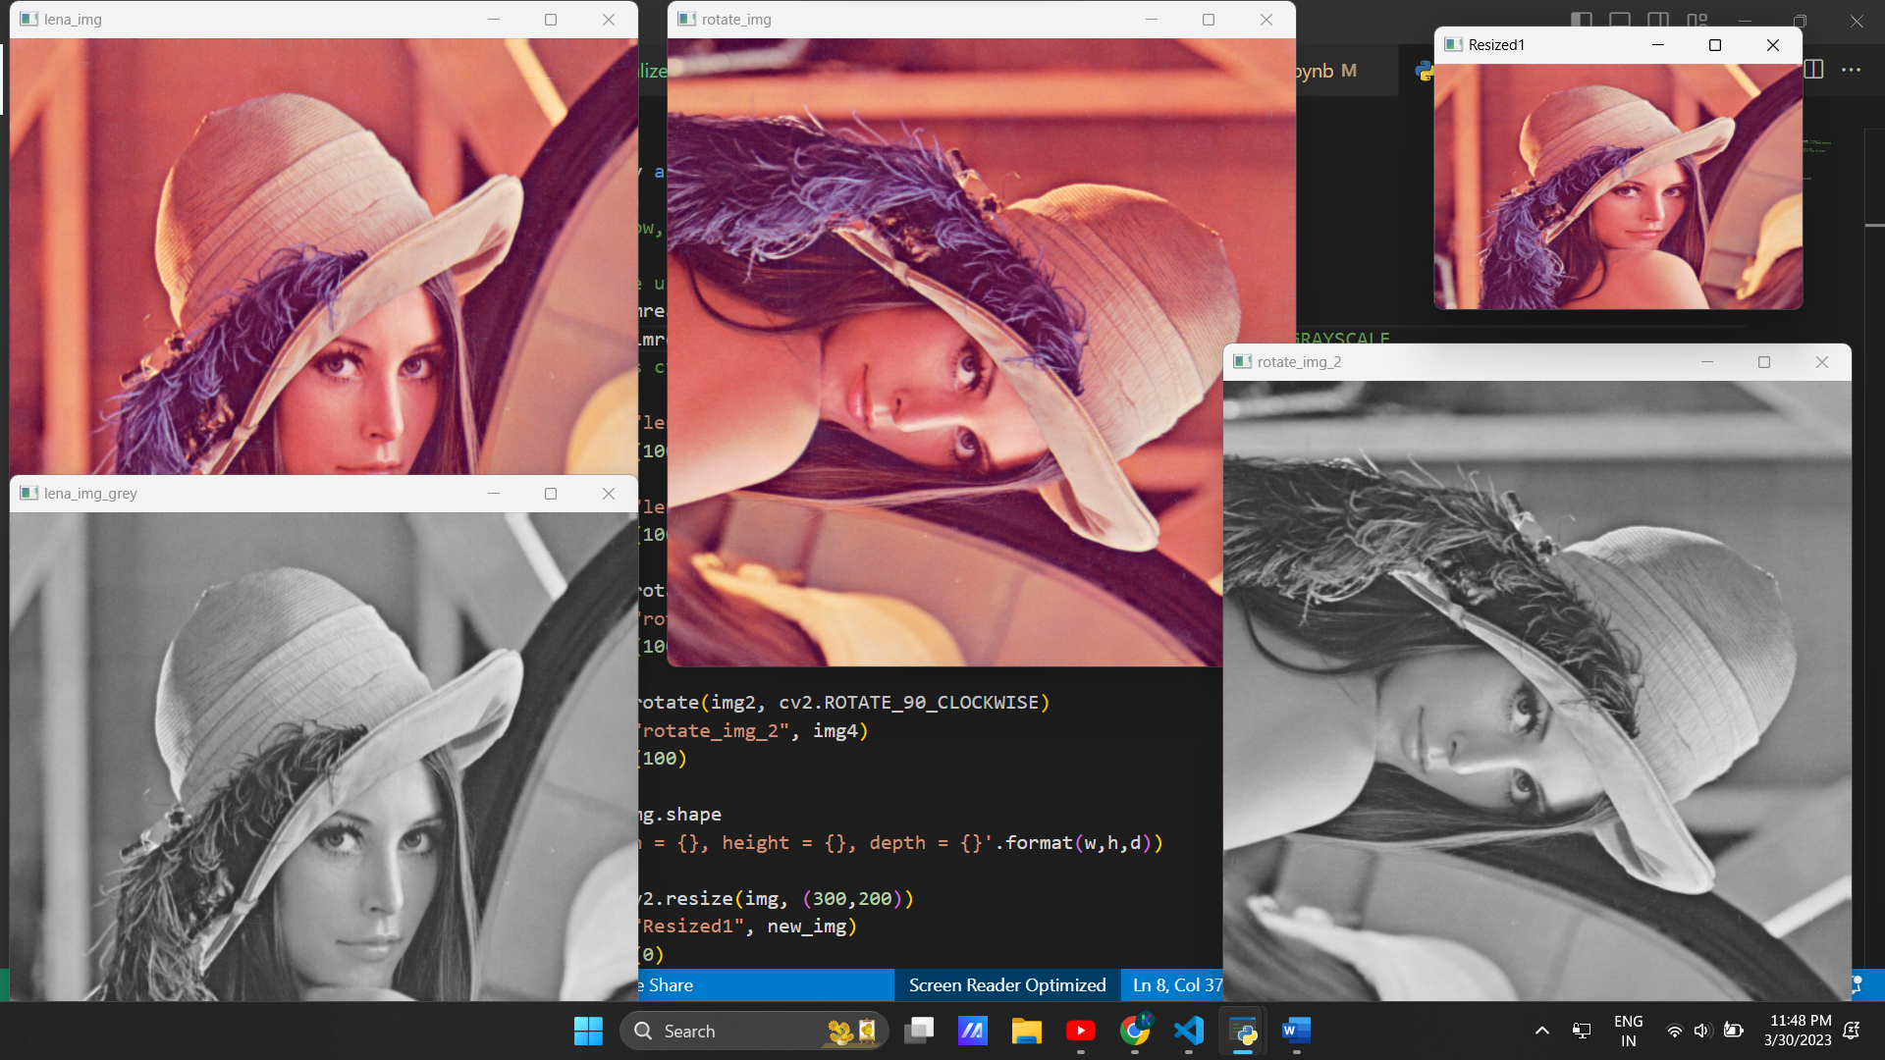

Practical 2:-

import cv2

img1 = cv2.imread('./assets/Lenna.png', 1)

img2 = cv2.imread('./assets/camera_man.jpg', 1)

(h,w,d)=img1.shape

print(f"Height= {h}\nWidth= {w}\nDepth= {d}")

(h,w,d)=img2.shape

print(f"Height= {h}\nWidth= {w}\nDepth= {d}")

#resize of image to add them

new = cv2.resize(img2, (512, 512))

#normal addition

add = cv2.add(img1,new)

cv2.imshow('Addition', add)

#Weighted addition

addw = cv2.addWeighted(img1, 0.2, new, 0.8, 0)

cv2.imshow('Weighted Addition', addw)

#normal subtraction

sub = cv2.subtract(img1,new)

cv2.imshow('Subtraction',sub)

#multiplication

mul = cv2.multiply(img1, new)

cv2.imshow('Multiplication',mul)

#division

div = cv2.divide(img1, new)

cv2.imshow('Division',div)

cv2.waitKey(0)

cv2.destroyAllWindows()

Output:-

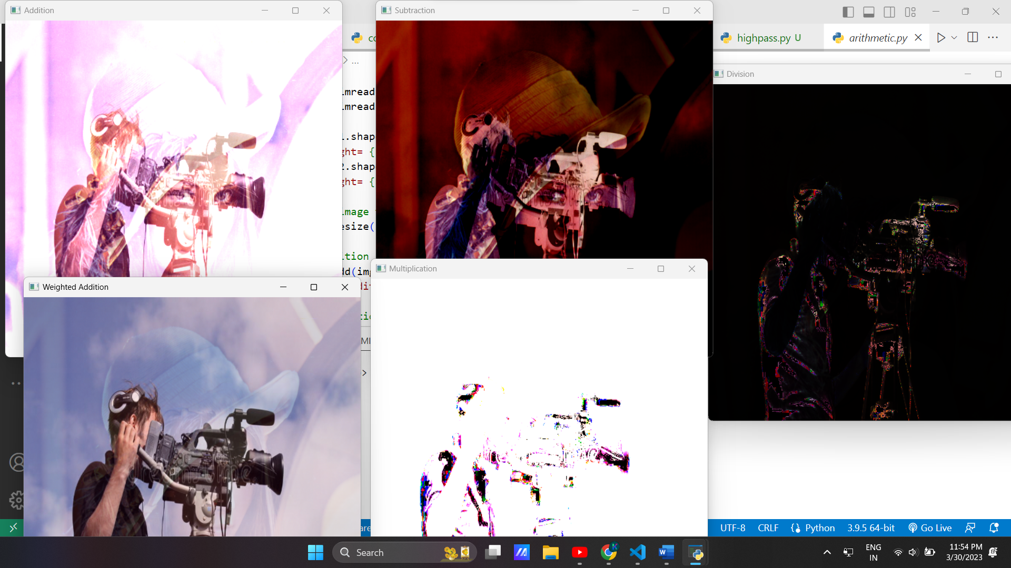

Practical 3:-

Digital Negative:-

# Point to point operations

# 1. Digital Negative of binary image (0->1 and vice versa)

import cv2

img = cv2.imread('assets\hands.jpeg', 1)

img1 = cv2.resize(img, (500,600))

ret, b1 = cv2.threshold(img1, 127, 255, cv2.THRESH_BINARY)      # converting greyscale to binary

cv2.imshow('Original', img1)

cv2.imshow('Binary', b1)

cv2.waitKey(0)

img2 = cv2.bitwise_not(b1)

cv2.imshow("Digital Negative", img2)

cv2.waitKey(0)

cv2.destroyAllWindows()

Output:-

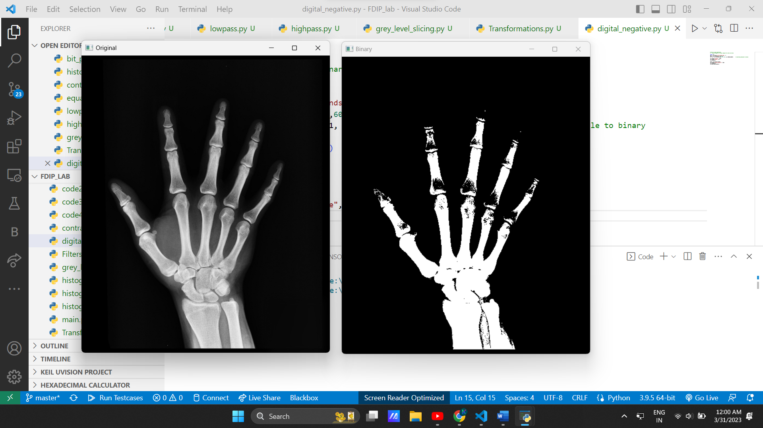

Transformation:-

# Point to point operations

# 2. Log Transformation

# 3. Power Law Transformation / Law Transformation

import cv2

import numpy as np

img = cv2.imread('assets\hands.jpeg', 1)

img1 = cv2.resize(img, (500,600))

cv2.imshow("Original Image", img1)

c = 255/np.log(1 + np.max(img1))

log_transformed = c*(np.log(1+img1))

log_transformed = np.array(log_transformed, dtype = np.uint8)

cv2.imshow("Log Transformed Image", log_transformed)

cv2.waitKey(0)

cv2.destroyAllWindows()

# Trying 4 gamma values.

for gamma in [0.1, 0.5, 1.5, 2.5, 3.5, 5.5]:

    img2 = np.array(255 * (img1 / 255) ** gamma, dtype='uint8')   # Apply gamma correction.

    cv2.imshow('gamma_transformed ' + str(gamma) + '.jpg', img2)

    cv2.waitKey(0)

cv2.destroyAllWindows()

Output:-

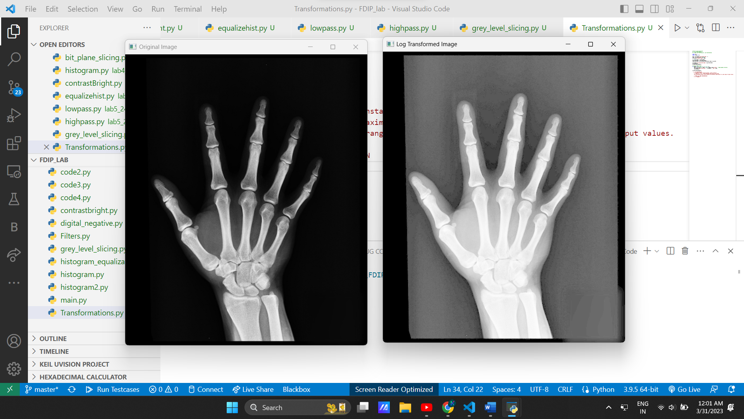

Bit Plane Slicing:-

import numpy as np

import cv2 as cv

img=cv.imread("./assets/camera_man1.png",0)

[w,h]=img.shape

img1=np.zeros([w,h,3],dtype=np.uint8)

img2=np.zeros([w,h,3],dtype=np.uint8)

img3=np.zeros([w,h,3],dtype=np.uint8)

img4=np.zeros([w,h,3],dtype=np.uint8)

img5=np.zeros([w,h,3],dtype=np.uint8)

img6=np.zeros([w,h,3],dtype=np.uint8)

img7=np.zeros([w,h,3],dtype=np.uint8)

img8=np.zeros([w,h,3],dtype=np.uint8)

def bitget(nbr,pos):

    return (nbr>>pos) & 1

planes=8

for i in range(0,w):

    for j in range(0,h):

        for p in range(planes-1,-1,-1):

            if p==7:

                img1[i][j]=255*bitget(img[i][j],p)

            elif p==6:

                img2[i][j]=255*bitget(img[i][j],p)

            elif p==5:

                img3[i][j]=255*bitget(img[i][j],p)

            elif p==4:

                img4[i][j]=255*bitget(img[i][j],p)

            elif p==3:

                img5[i][j]=255*bitget(img[i][j],p)

            elif p==2:

                img6[i][j]=255*bitget(img[i][j],p)

            elif p==1:

                img7[i][j]=255*bitget(img[i][j],p)

            else:

                img8[i][j]=255*bitget(img[i][j],p)

cv.imshow('Plane 08',img1)

cv.imshow('Plane 07',img2)

cv.imshow('Plane 06',img3)

cv.imshow('Plane 05',img4)

cv.imshow('Plane 04',img5)

cv.imshow('Plane 03',img6)

cv.imshow('Plane 02',img7)

cv.imshow('Plane 01',img8)

cv.waitKey(0)

cv.destroyAllWindows

Output:-

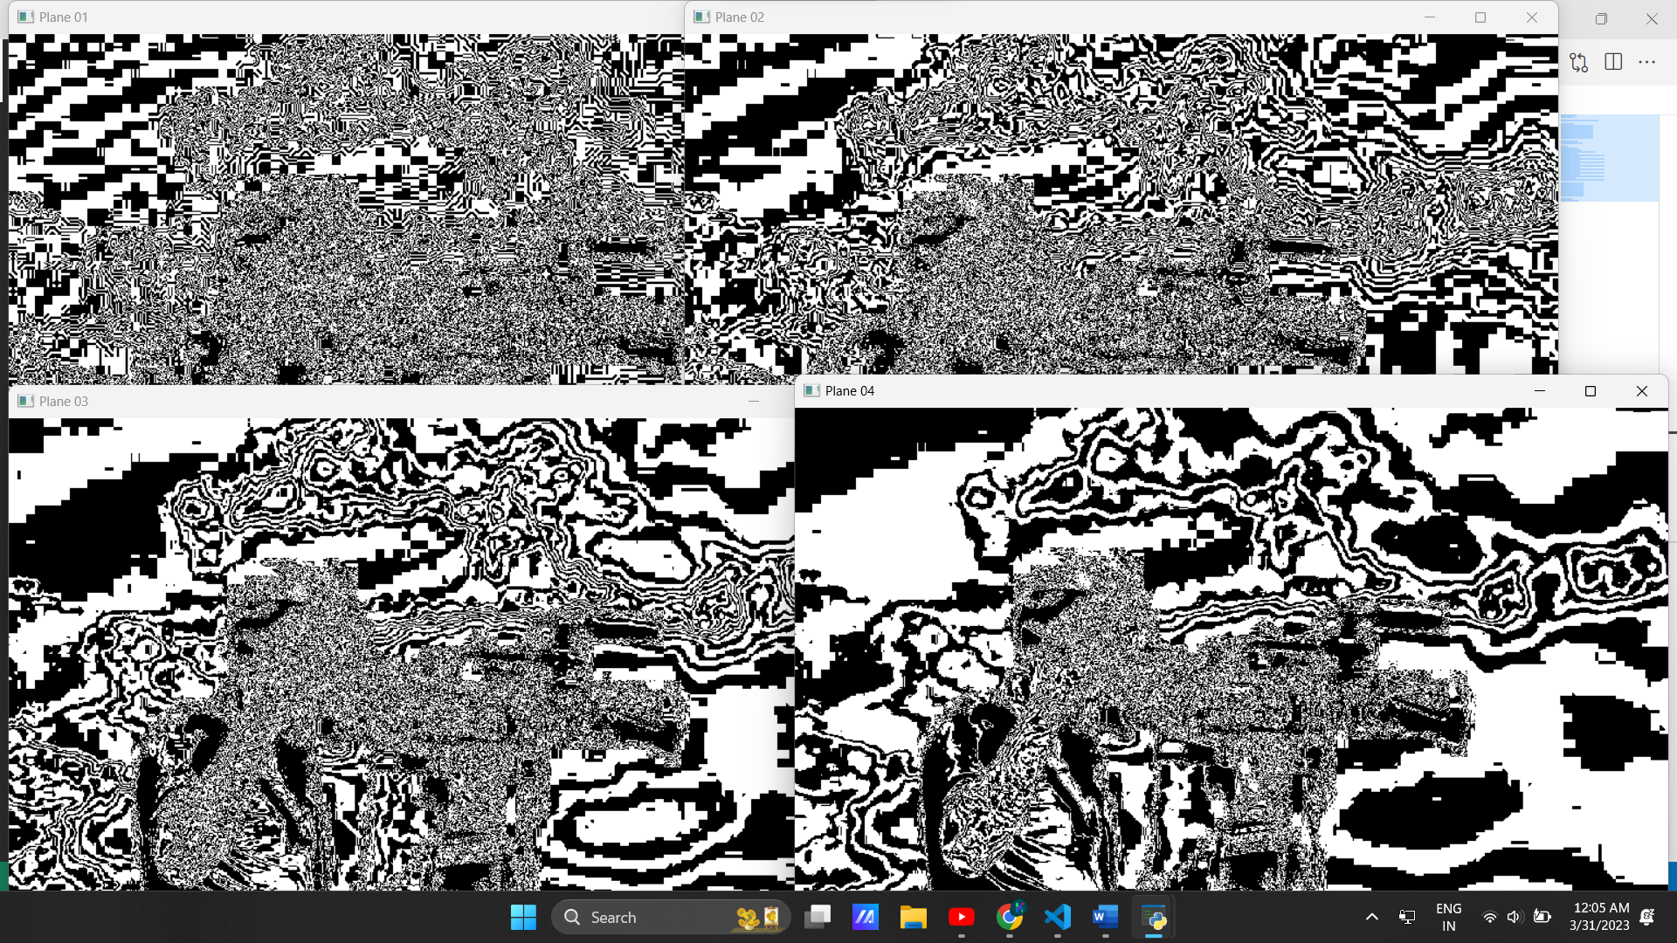

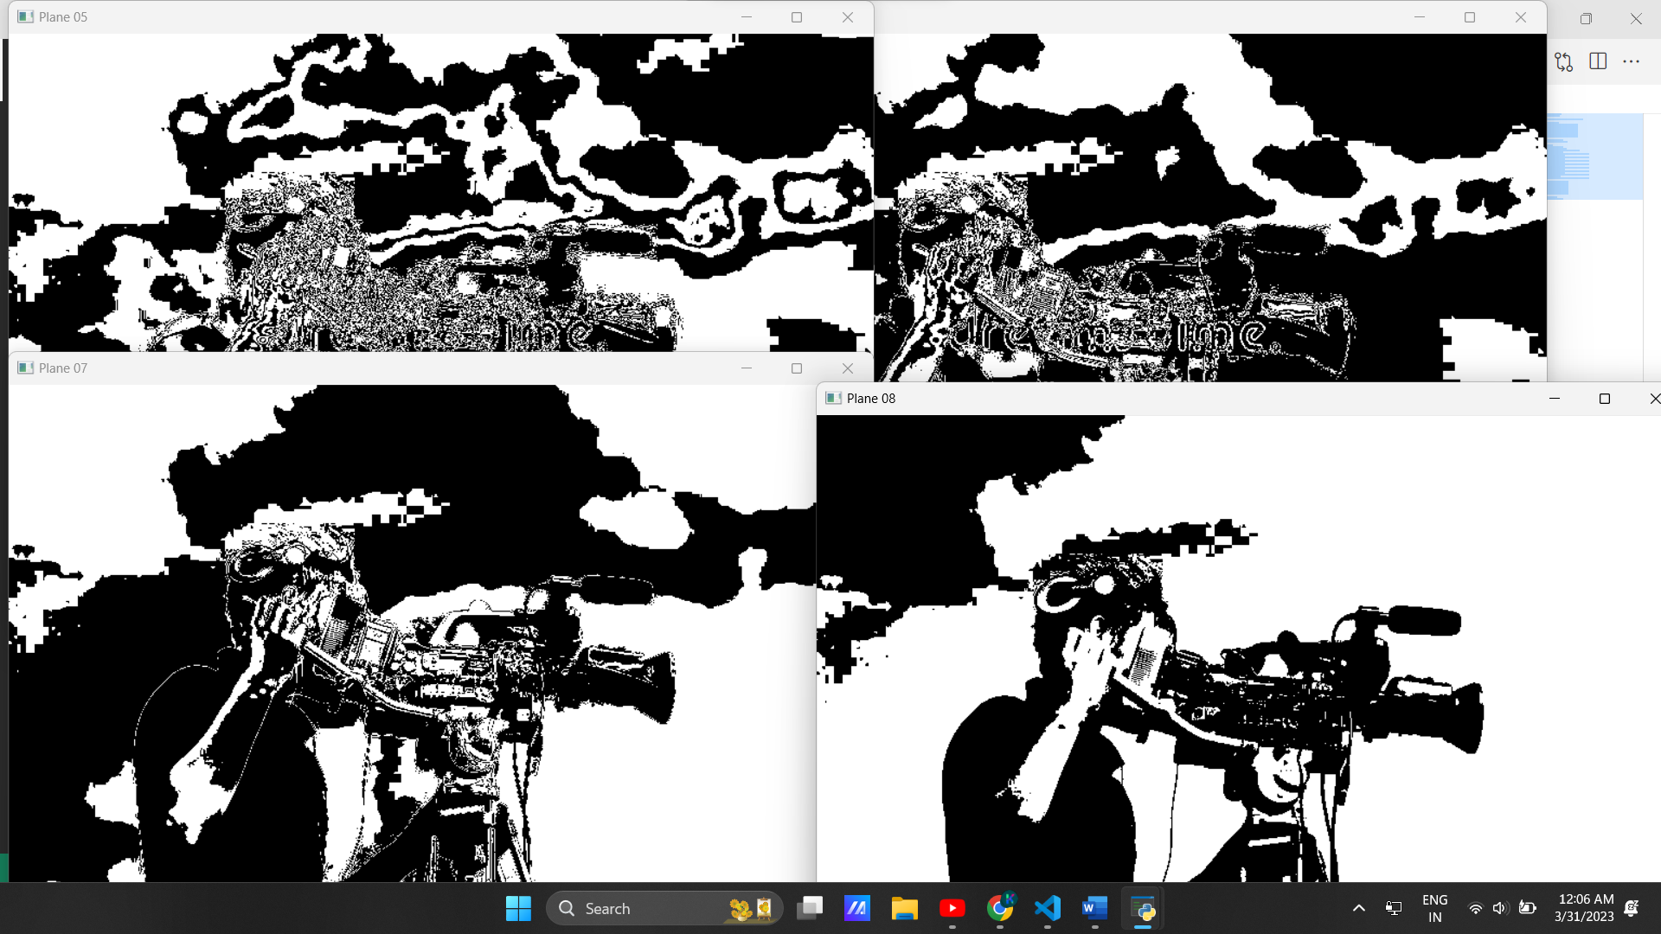

Grey Level Slicing:-

# Point to point operations

# 4. Grey Level Slicing

import cv2

img = cv2.imread(r"assets\hands.jpeg", 0)

img1 = cv2.resize(img, (500, 600))

cv2.imshow('Original Image', img1)

w,h = img1.shape

min_range = 80   # Specify the min and max range

max_range = 160

for i in range(0,w):

    for j in range(0,h):

        if img1[i][j]>min_range and img1[i][j]<max_range:

            img1[i][j] = 220

cv2.imshow('Grey Level Sliced Image', img1)

cv2.waitKey(0)

cv2.destroyAllWindows()

Output:-

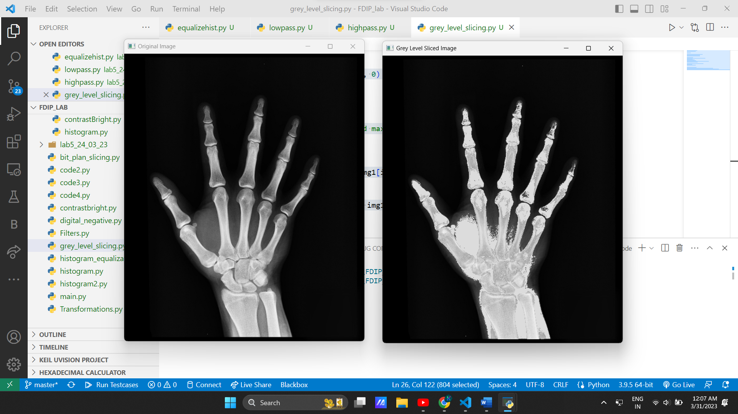

Practical 4:-

Histogram:-

from matplotlib import pyplot as plt

import cv2 as cv

img=cv.imread("./assets/Lenna.png")

img2=cv.imread("./assets/Lenna.png",0)

cv.imshow('Image1',img)

cv.imshow('Image2',img2)

histr=cv.calcHist([img],[0],None,[256],[0,256])

histr2=cv.calcHist([img2],[0],None,[256],[0,256])

plt.title("Image")

plt.xlabel('bins')

plt.ylabel('No. of pixels')

plt.plot(histr)

plt.plot(histr2)

plt.show()

cv.waitKey(0)

cv.destroyAllWindows()

Output:-

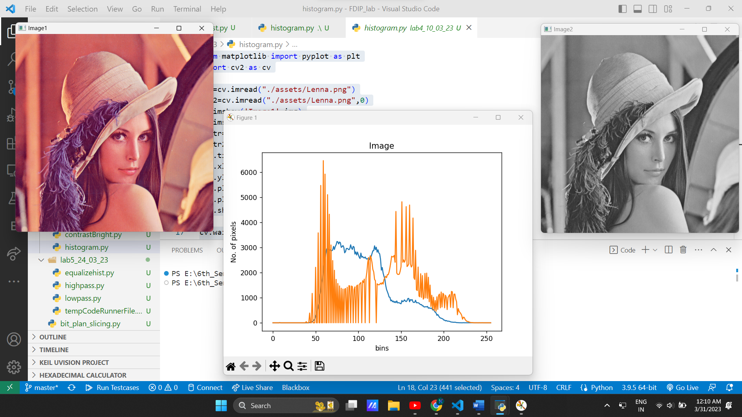

Contrast Bright:-

import cv2 as cv

import matplotlib.pyplot as plt

import numpy as np

image=cv.imread("./assets/preview500.jpg")

plt.subplot(1,2,1)

plt.title("Original")

plt.imshow(image)

alpha=1.5

beta=50

image2=cv.convertScaleAbs(image,alpha=alpha,beta=beta)

cv.imwrite("Brightness and contrast.jpg",image2)

plt.subplot(1,2,2)

plt.title("Brightness and contrast")

plt.imshow(image2)

plt.show()

cv.waitKey(0)

cv.destroyAllWindows()

Output:-

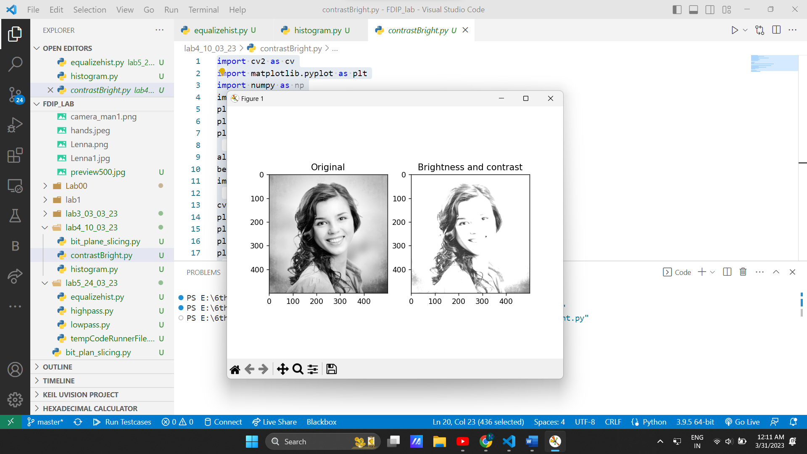

Histogram Eqalization:-

# import Opencv

import cv2

# import Numpy

import numpy as np

# read a image using imread

# read image

path = "assets\camera_man.jpg"

flag = 0

img = cv2.imread(path, flag)

# creating a Histograms Equalization

# of a image using cv2.equalizeHist()

equ = cv2.equalizeHist(img)

# stacking images side-by-side

res = np.hstack((img, equ))

# show image input vs output

cv2.imshow('cameraman', res)

cv2.waitKey(0)

cv2.destroyAllWindows()

Output:-

